**VSP TECHNOLOGIES**



**Flat no. 103, LG.Paradise, Road no. 5, Official Colony, Srinagar, Gajuwaka, Visakhapatnam , Andhra Pradesh - 530026**

**Satish – 8886503423 Email:[vsptechcrt@gmail.com](mailto:vsptechcrt@gmail.com) Balaji – 9849275785**

**About us:**

We, VSP Technologies have been covered to place a lot of aspirants in various MNC’s across India. We are committed to provide top-notch trainings to the needs.

**MISSION**

* To train with a world class quality of education making them a complete personality
* To sharpen the participants intelligence and motivating them to be spiritual and ethical
* To create a suitable atmosphere to enhance their skills

**VISION**

* Igniting students’ minds through quality education.
* To impart skills that empowers value-based education

**Design:**

All of modules are designed with industry specific requirements. Based on student level our expert faculty provide training.

**Implementation:**

Using our LMS platform we provide practice test for every topic. At the time of training we will explain each and every company patterns and coding level.

For example after completion of Arrays topic we will provide practice link as follows:

<https://p.hck.re/Ch8s>

and provides student reports as follows:

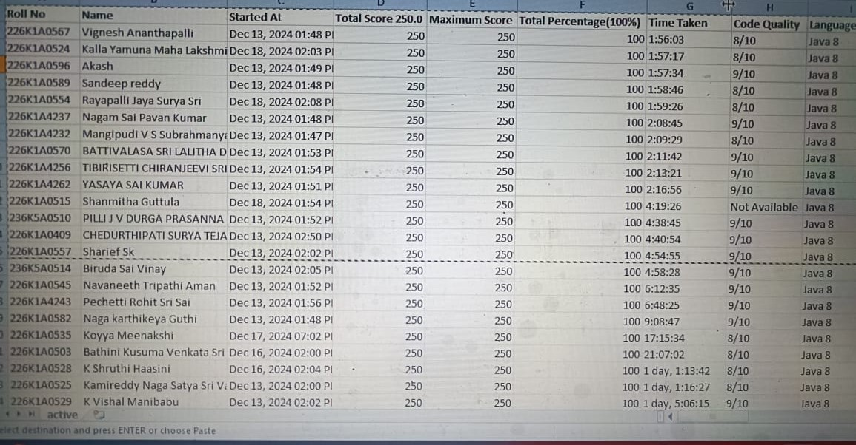

**To**

**The Training and Placement Officer,**

**JNTUA**

**Kalikiri**

**Proposed Program:**

**Course Title** : CRT

**Course Objective** : To improve specific language skills and coding skills using an effective tool.

**Duration** : Depends on College requirement

|  |  |
| --- | --- |
| **CRT Training details:** |  |
| **Technical Training** | CRT |
| **Program duration:** | 12 |
| **Program Cost (Trainer per day)** | For Technical : 7000  For Aptitude : 6000  For Verbal : 6000 |
| **Target outcome:** | Continuous performance monitoring using LMS.  Test and Home work.  <https://p.hck.re/bRQX>  Coding practice links using Hacker rank based on topic wise.  Ex: [www.hackerrank.com/walys-conditions1](http://www.hackerrank.com/walys-conditions1)  Competitive coding using Hacker rank, Leet code and work@tech |

**Schedule:**

|  |  |  |  |  |  |
| --- | --- | --- | --- | --- | --- |
| **S.No** | **DATE** | **TIME** | **BATCH 1** | **BATCH2** | **BATCH3** |
| 1 | 21-02-25 | FN | Introduction to Python, Tokens – Identifiers, keywords, Operators | Introduction on Communication Skills, Efficiency, Fluency and Profiency + prepositions(a test) | Number systems and LCM and HCF |
| AN | Number systems and LCM and HCF | Introduction to Python, Tokens – Identifiers, keywords, Operators | Introduction on Communication Skills, Efficiency, Fluency and Profiency + prepositions(a test) |
| 2 | 22-02-25 | FN | Introduction on Communication Skills, Efficiency, Fluency and Profiency + prepositions(a test) | Number systems and LCM and HCF | Introduction to Python, Tokens – Identifiers, keywords, Operators |
| AN | Input and output statements, Basic programs, Conditional statements | Basic steps(test) + classification of Monophthongs ( Accent), Nouns(test) + Classification on Consonants ( Accent) | Percentages and Proft and loss |
| 3 | 23-02-25 | FN | Percentages and Proft and loss | Input and output statements, Basic programs, Conditional statements | Basic steps(test) + classification of Monophthongs ( Accent), Nouns(test) + Classification on Consonants ( Accent) |
| AN | Basic steps(test) + classification of Monophthongs ( Accent), Nouns(test) + Classification on Consonants ( Accent) | Percentages and Proft and loss | Input and output statements, Basic programs, Conditional statements |
| 4 | 24-02-25 | FN | Loops – while,for  Loops related programs | Pronouns(test) + classification on Diphthongs ( Accent) | Directions and Blood relations & clocks |
| AN | Directions and Blood relations & clocks | Loops – while,for  Loops related programs | Pronouns(test) + classification on Diphthongs ( Accent) |
| 5 | 25-02-25 | FN | Pronouns(test) + classification on Diphthongs ( Accent) | Directions and Blood relations & clocks | Loops – while,for  Loops related programs |
| AN | Jumping statements- break, continue, pass  Nested loops related programs | Adjectives (Articles, comparison- a test)+ Aspiration ( Accent) | Data Interpretations and SI-CI |
| 6 | 26-02-25 | FN | Data Interpretations and SI-CI | Jumping statements- break, continue, pass  Nested loops related programs | Adjectives (Articles, comparison- a test)+ Aspiration ( Accent) |
| AN | Adjectives (Articles, comparison- a test)+ Aspiration ( Accent) | Data Interpretations and SI-CI | Jumping statements- break, continue, pass  Nested loops related programs |
| 7 | 27-02-25 | FN | Functions – types of functions, types of arguments, scope of variables, Lambda functions | Verbs ( Tense, Tags, Voice,speech) – Structures  Word Stress ( Accent )  Verbs – usage, Agreements (test), JAMS  Intonation ( Accent) | Time and work & Pipes and Cisterns |
| AN | Time and work & Pipes and Cisterns | Functions – types of functions, types of arguments, scope of variables, Lambda functions | Verbs ( Tense, Tags, Voice,speech) – Structures  Word Stress ( Accent )  Verbs – usage, Agreements (test), JAMS  Intonation ( Accent) |
| 8 | 28-02-25 | FN | Verbs ( Tense, Tags, Voice,speech) – Structures  Word Stress(Accent )  Verbs – usage, Agreements (test), JAMS, Intonation( Accent) | Time and work & Pipes and Cisterns | Functions – types of functions, types of arguments, scope of variables, Lambda functions |
| AN | Introduction to list, list functions, List related company programs | Adverbs, conjunctions, RC - tests  Informal GDs, Spotting Errors, RC ( tests) | Number series and letter series and coding and decoding ,odd man out |
| 9 | 01-03-25 | FN | Number series and letter series and coding and decoding ,odd man out | Introduction to list, list functions, List related company programs | Adverbs, conjunctions, RC - tests  Informal GDs, Spotting Errors, RC ( tests) |
|  | AN | Adverbs, conjunctions, RC - tests  Informal GDs, Spotting Errors, RC ( tests) | Number series and letter series and coding and decoding ,odd man out | Introduction to list, list functions, List related company programs |
| 10 | 02-03-25 | FN | Tuple data structure, set data structure, dictionary data structure | Jumbleds, Cloze Test, RC( tests)  Presentation Skills | Time and Distance ,Problems and On trains ,Boats and Streams |
|  |  | AN | Time and Distance ,Problems and On trains ,Boats and Streams | Tuple data structure, set data structure, dictionary data structure | Jumbleds, Cloze Test, RC( tests)  Presentation Skills |
| 11 | 03-03-25 | FN | Jumbleds, Cloze Test, RC( tests)  Presentation Skills | Time and Distance ,Problems and On trains ,Boats and Streams | Tuple data structure, set data structure, dictionary data structure |
|  |  | AN | String, String related functions, String related company specific programs | Sentence selection, Sentence Completion( tests)  Role plays | Permutations and Combinations |
| 12 | 04-03-25 | FN | Permutations and Combinations | String, String related functions, String related company specific programs | Sentence selection, Sentence Completion( tests)  Role plays |
|  |  | AN | Sentence selection, Sentence Completion( tests)  Role plays | Permutations and Combinations | String, String related functions, String related company specific programs |
| 13 | 05-03-25 | FN | Company specific programs | Resume, E-mail,  Interview Skills | Probability and Data sufficiency |
|  |  | AN | Probability and Data sufficiency | Company specific programs | Resume, E-mail,  Interview Skills |
| 14 | 06-03-25 | FN | Resume, E-mail,  Interview Skills | Probability and Data sufficiency | Company specific programs |
|  |  | AN | Company specific programs | GDs | Statement and conclusions and ranking and element series |